**Polycom VVX 150 - Guide**

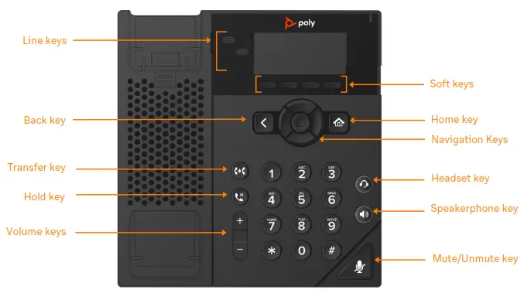

|  |  |
| --- | --- |
| Lines screen example. Displays phone lines, Favorites, and conditional soft keys. | **Lines Screen**  Displays Phone lines, Favorites, and conditional Soft keys.  **Available anytime**. |
| Home screen example. Displays messages, settings, and information. | **Home Screen**  Displays Messages, Settings, and Information.  **Available anytime**. |
| Calls screen example. It displays all active and held calls. It also provides soft key functions to help manage the call. | **Calls Screen**  Displays all Active and Held calls. |

**Switch among Phone Screens**

You can view any screen on your phone from other screens.

## To switch between screens:

**»** Do one of the following:

* Press the Home key  to display the Home screen from the Lines, Calls or Active Call screen.
* Press the **Lines** soft key to access the Lines screen from the Calls or New Call Screen.
* Press the **Calls** soft key to access the Calls screen from the Lines screen.
* On VVX 150 phones, press the **C > L** soft key to display the Lines screen from the Calls screen.
* On VVX 150 phones, press the **L > C** soft key to display the Calls screen from the Lines screen.

**Place Calls**

You can only have one active call in progress on your phone.

## To place a call:

**»** Do one of the following:

* Pick up the handset, press  or , enter the phone number, and press **Send**.
* Enter the phone number, press **Dial** and pick up the handset, or press .
* From the Lines screen, press the Line key, enter the phone number, and select **Send**.
* From the Home screen, select **New Call**, enter the phone number, and press **Send**.
* Select a **Favorite** from the home screen.
* Select a contact from the **Recent Calls** and

**Contact Directory**.

# Answer Calls

You can answer calls on your phone using the handset, speakerphone, or a headset.

## To answer a call:

**»** Do one of the following:

* To answer with the speakerphone, press  or press **Answer** soft key.
* To answer with the handset, pick up the handset.
* To answer with a headset, press .

# End Calls

You can end active calls at any time. To end a held call, you must resume the call first.

## To end an active call:

**»** Replace the handset in the cradle, press  or , or press the **End Call** soft key.

## To end a held call:

1. Select the held call and press **Resume.**
2. Press **End Call**.

# Hold and Resume Calls

You can have multiple calls on hold and resume a call at any time.

## To hold a call:

**»** Select the call and press the **Hold** soft key.

## To resume a call

**»** Select the call and press the **Resume** soft key.

# Transfer Calls

You can transfer calls to any contact.

## To transfer a call:

1. Press and hold the **Transfer** soft key.
2. Choose **Blind** or **Consultative**. Consultative transfers allow you to speak to the person who will receive the call before transferring the call.
3. Dial a number or choose a contact.

If you chose **Blind**, the call is transferred immediately.

If you chose **Consultative**, press the **Transfer** soft key after speaking with your contact.

# Forward Calls

You can forward an incoming call to a contact or forward all incoming calls to a contact.

## To forward an incoming call:

1. On the **Incoming Call** screen, select

## Forward.

1. Enter your contact’s number and select

## Forward.

**To forward all incoming calls:**

1. On the Home screen, select **Forward**.
2. If you have more than one line, select a line.
3. Choose either **Always**, **No Answer**, or **Busy**.
4. Enter a contact’s number and select **Enable**.

If you choose **No Answer**, you can enter the number of rings before the call is forwarded.

## To disable call forwarding:

1. Select **Forward** or press the **Fwd** soft key.
2. If you have more than one line, select a line.
3. Choose your forwarding type and select

**Disable**.

## View Recent Calls

You can view recent placed, received, and missed calls.

## To view recent calls:

**»** Navigate to **Directories > Recent Calls**.

# View the Contact Directory

You can view and add contacts to the Contact Directory.

## To view the Contact Directory:

**»** From the Home screen select **Directories**

**>Contact Directory**.

## To add a contact to the Contact Directory:

1. Navigate to **Directories > Contact Directory**
2. In the Contact Directory, select **Add**.
3. Enter the contact’s information and select

## Save.

You can enter a number between 1 and 99 in the

**Favorite Index** field to make a contact a favorite.

# Listen to Voicemail

When you have new voicemail messages, the red voicemail indicator will blink.

## To listen to voicemail:

1. At the dial tone, dial **\*95**, or
2. On the Home screen, select **Messages**.
3. Select **Message Center > Connect**.

**Enable Do Not Disturb**

You can enable Do Not Disturb to prevent your phone from ringing and to send all incoming calls directly to voicemail.

## To enable or disable Do Not Disturb:

**»** On the Home screen or Idle Screen, select

**DND**.